This is a typical release form used to secure permission to use an individual’s likeness with or without identification. From Public Relations Writing & Media Techniques (Fourth Edition) by Dennis Wilcox.

Photo Release Form
Surrey Youth Safety Council
Surrey BC, V3W
Permission to Use Photograph
Subject: Release Form
Location: City of Surrey
I grant to [SYSC] its representatives and employees the right to take photographs of me and my property in connection with the above-identified subject. I authorize [SYSC], its assigns and transferees to copyright, use and publish the same in print and/or electronically.

I agree that [SYSC] may use such photographs of me with or without my name and for any lawful purpose, including for example such purposes as publicity, illustration, advertising, and Web content.

I have read and understand the above:

Signature _________________________________

Printed name ______________________________

Organization Name (if applicable) __________________________

Address __________________________________

Date _____________________________________

Signature, parent or guardian _______________________ (if under age 18)

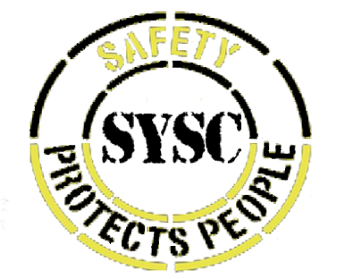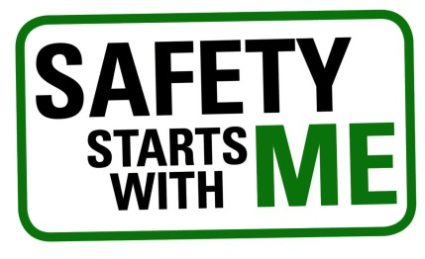
Approved by Jashaun Grewal – SYSC Leader

