February 2015 - Present 2017

Surrey Youth Safety Council
(SYSC)
Surrey, BC

Dear businesses/organizations,

SYSC will be hosting school workshops throughout Surrey, and a Banquet Hall Event throughout the coming months. In order to ensure the success of these very important events, we are seeking contributions to help defray the costs associated with the event, so that all funds raised can go directly toward the community.

Generous donors like you are the key to our success and make it possible for SYSC to provide local individuals and families in need with assistance and critical services. We hope that we can count on your support to help us reach our goals.

Our Goals:
-Raise safety awareness in Surrey
-Raise awareness for mental illness
-Reach out to those who haven’t received help
-Decrease youth related crime in Surrey

Your donation will be listed in our event program, as well as on our soon to be website. Any kind of donation is accepted as it goes back to the youth and our community. We thank you for your time and consideration.

Sincerely,

Jashaun Grewal
Leader/Director of SYSC

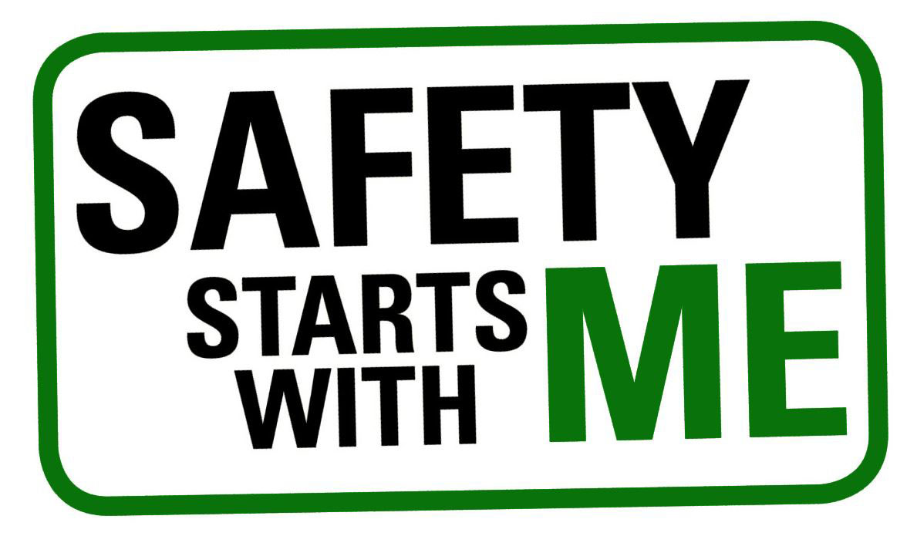

Surrey Youth Safety Council: 604-781-2550, surreyyouthsafetycouncil@gmail.com

